# Lab 5: Create an API Portal

Lab 5: Create an API Portal

Overview

Step 1: Create and customize the API Portal

Step 2: Manage the API Portal settings

Step 3: Adding a Getting Started Page

Step 4: Create a Notebook

Summary

## Overview

Now that we’ve designed your order entry API in RAML, we would like to engage your customers by developing an API portal. The API Portal is part of your API management life-cycle that enables developers to discover and learn how to use your API. They can log in to the web-based API Portal to view the API, test it (using the RAML console) and view documented use cases.

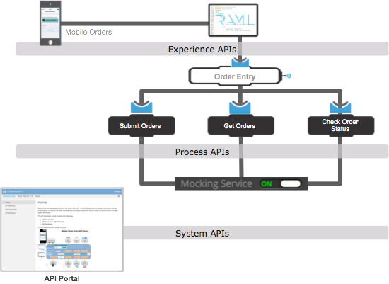

## Step 1: Create and customize the API Portal

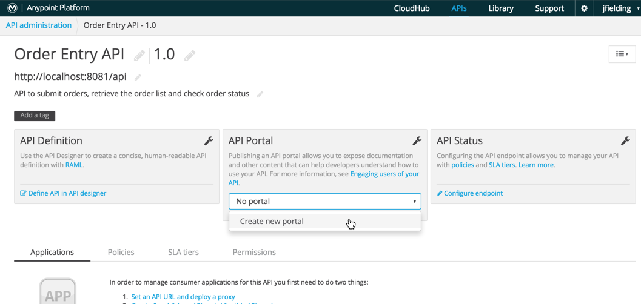

1. Go to the browser.
2. From the API administration page, select the **Order Entry API**.
3. On the **API Portal** section (in the middle of the API administration page) select “**Create New Portal**” from the pull down menu, This will take you to the administrative view of your API developer portal.

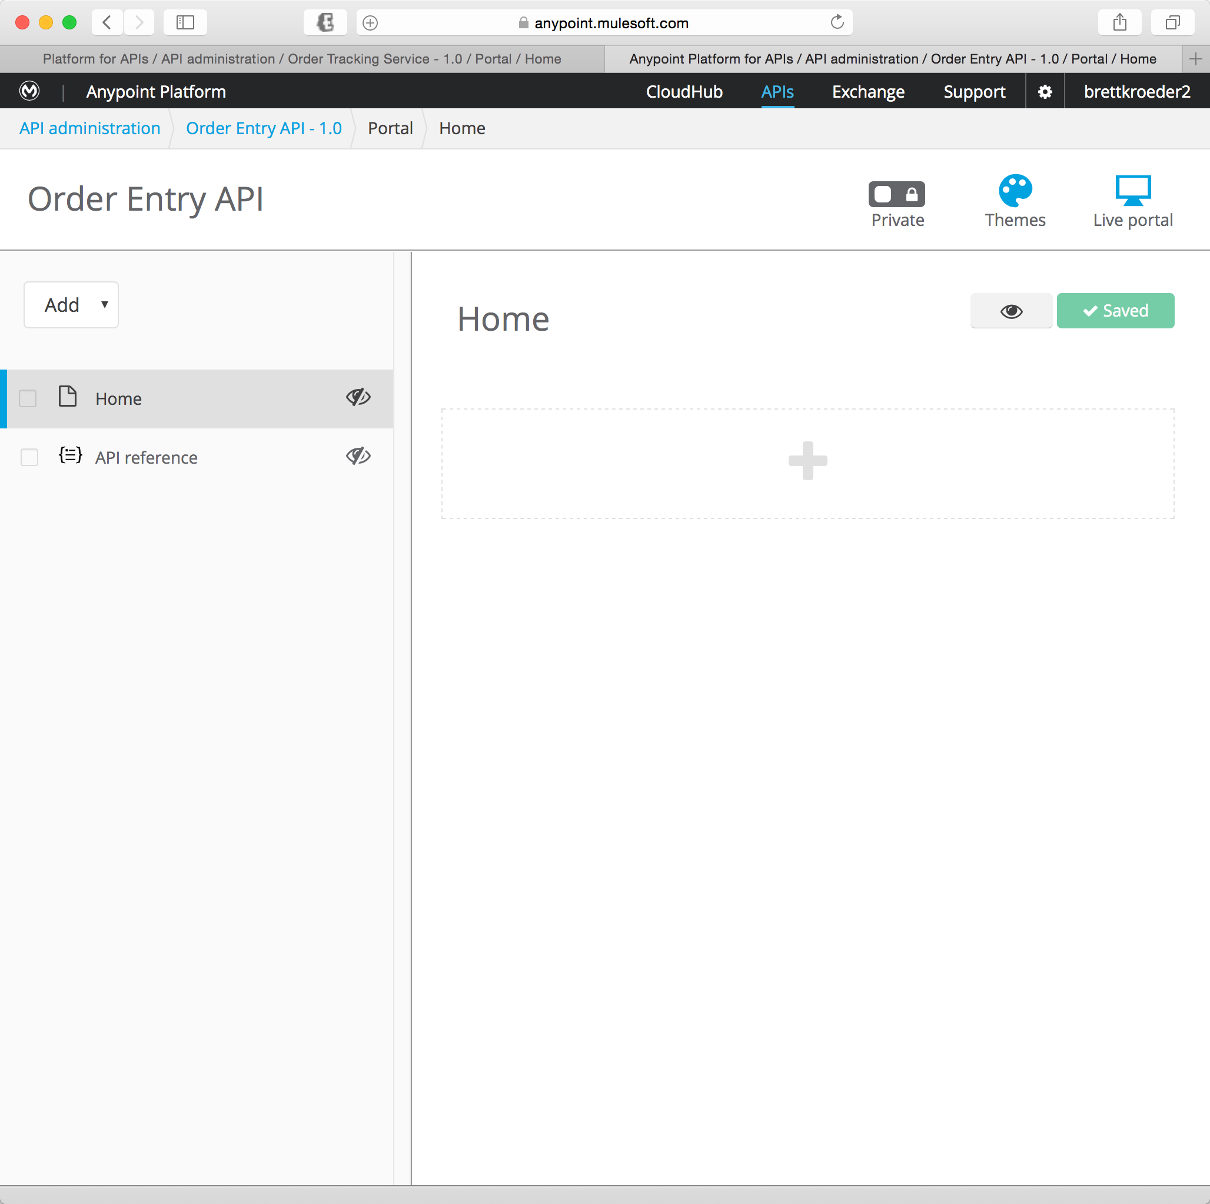

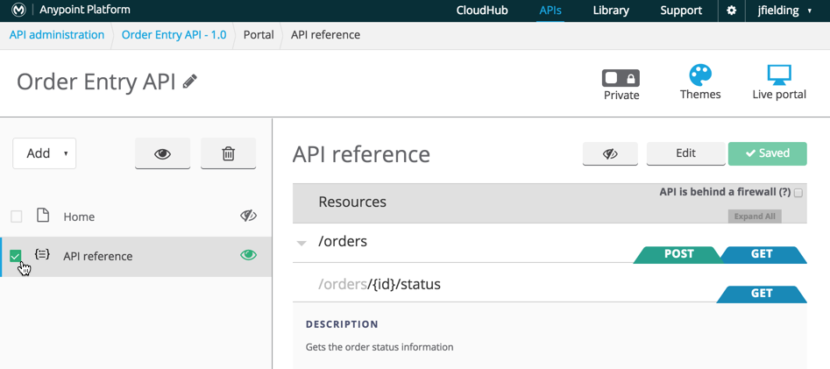

The administrative view of your developer portal allows you to customize the information that would be helpful to discover how to use your API. There are two pages added to your portal automatically. The first page is the Home page. It is a simple markdown page that can represent your main page. The second page contains a reference to your API that allows API consumers to use the same RAML console that you used earlier. You can therefore change the title in the page content from “API reference” to “RAML console” by clicking on it.

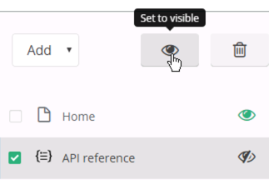

1. Select the checkboxes next to the Home and API reference pages.
2. Click theto set it to Visible.

## Step 2: Manage the API Portal settings

In this step, you will learn about the settings available to manage the API Portal.

In the top right corner, you’ll see 3 icons:

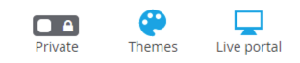

The first icon is for setting the API Portal to be either Public or Private.

* Public API Portals can be viewed by anyone, regardless of whether they are a member of your Anypoint Platform organization, whether they are signed in, or what permissions they have.
* Private API Portals can only be viewed by logged-in users of your Anypoint Platform organization who have Portal Viewer permissions for that API version.

When you first create a new portal, it is Private by default. You want to turn it Public,

1. Click the to make it Public.

|  |
| --- |
| **NOTE**: Unless you created the API version yourself, you must be explicitly granted Portal Viewer permissions. You also inherit Portal Viewer permissions if you are granted Portal Editor permissions for an API version. |

As soon as you make your portal Public, it appears on your Developer Portal to everyone, including anonymous users. Anyone will be able to discover your API and access its API Portal and see any documentation that you have published there.

If you want to make your API Portal private again,

1. Return to your Edit Portal view
2. Click****to toggle the portal back to private.

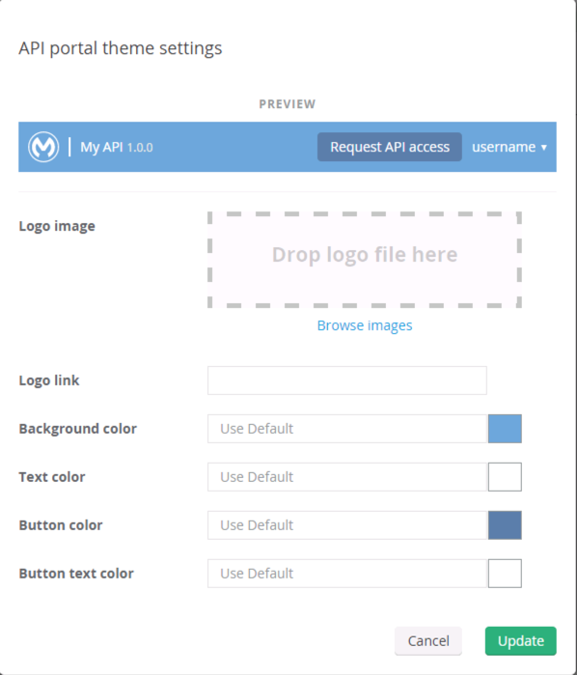

The  icon is for adjusting the look and feel of your API Portal. Feel free to customize your portal to your liking.

## Step 3: Adding a Getting Started Page

One of the first pages your API users will look for is the “Getting Started” page. We’ll pre-populate this page with the text below…

1. Copy all the text in the block below.

|  |
| --- |
| **NOTE**: You can copy-paste this from the soft-copy of the Workshop Guide, which is available as an icon on your Desktop.  **NOTE 2**: text can be formatted using [GitHub Flavored Markdown coding](https://help.github.com/articles/markdown-basics/) |

|  |
| --- |
| Welcome to the Order Entry API home page!    To get started with the API, please follow the steps below:    1. API Console: From the menu, select `RAML Console` to open the API console. Browse through the available resources, requests, responses and Try It.  2. Once you're familiar with the API, use the `API Notebook` option to start writing code to invoke the API. The notebook will generate most of the code for you! You can embed this JavaScript code into your script or share with others.  3. Once you're ready to move from the sandbox to real development, select the `Request Access.` Use the API Designer to play around with this API and get familiar with it. This will take you to the API Manager page where you can define your consumer, request a contract for this API with the higher SLA, and get a client ID.  4. Finally, to keep track of changes and notifications on this API, use the 'Follow API' option so you can be kept up-to-date.  5. Don't forget, there are other developers and the forum moderators on the 'Developer Forums' where you can ask any question and get answers!    If the resources on this portal have not answered your questions, enterprise customers can reach out to your support contact via support@mulesoft.com    Have fun with your app!! |

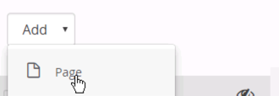

1. Select **Add New -> Page.**
2. Click where it says *New Page*.
3. Type **Getting Started** to rename the page.
4. Click on the “A”.
5. Paste the contents in the text box above into this box.

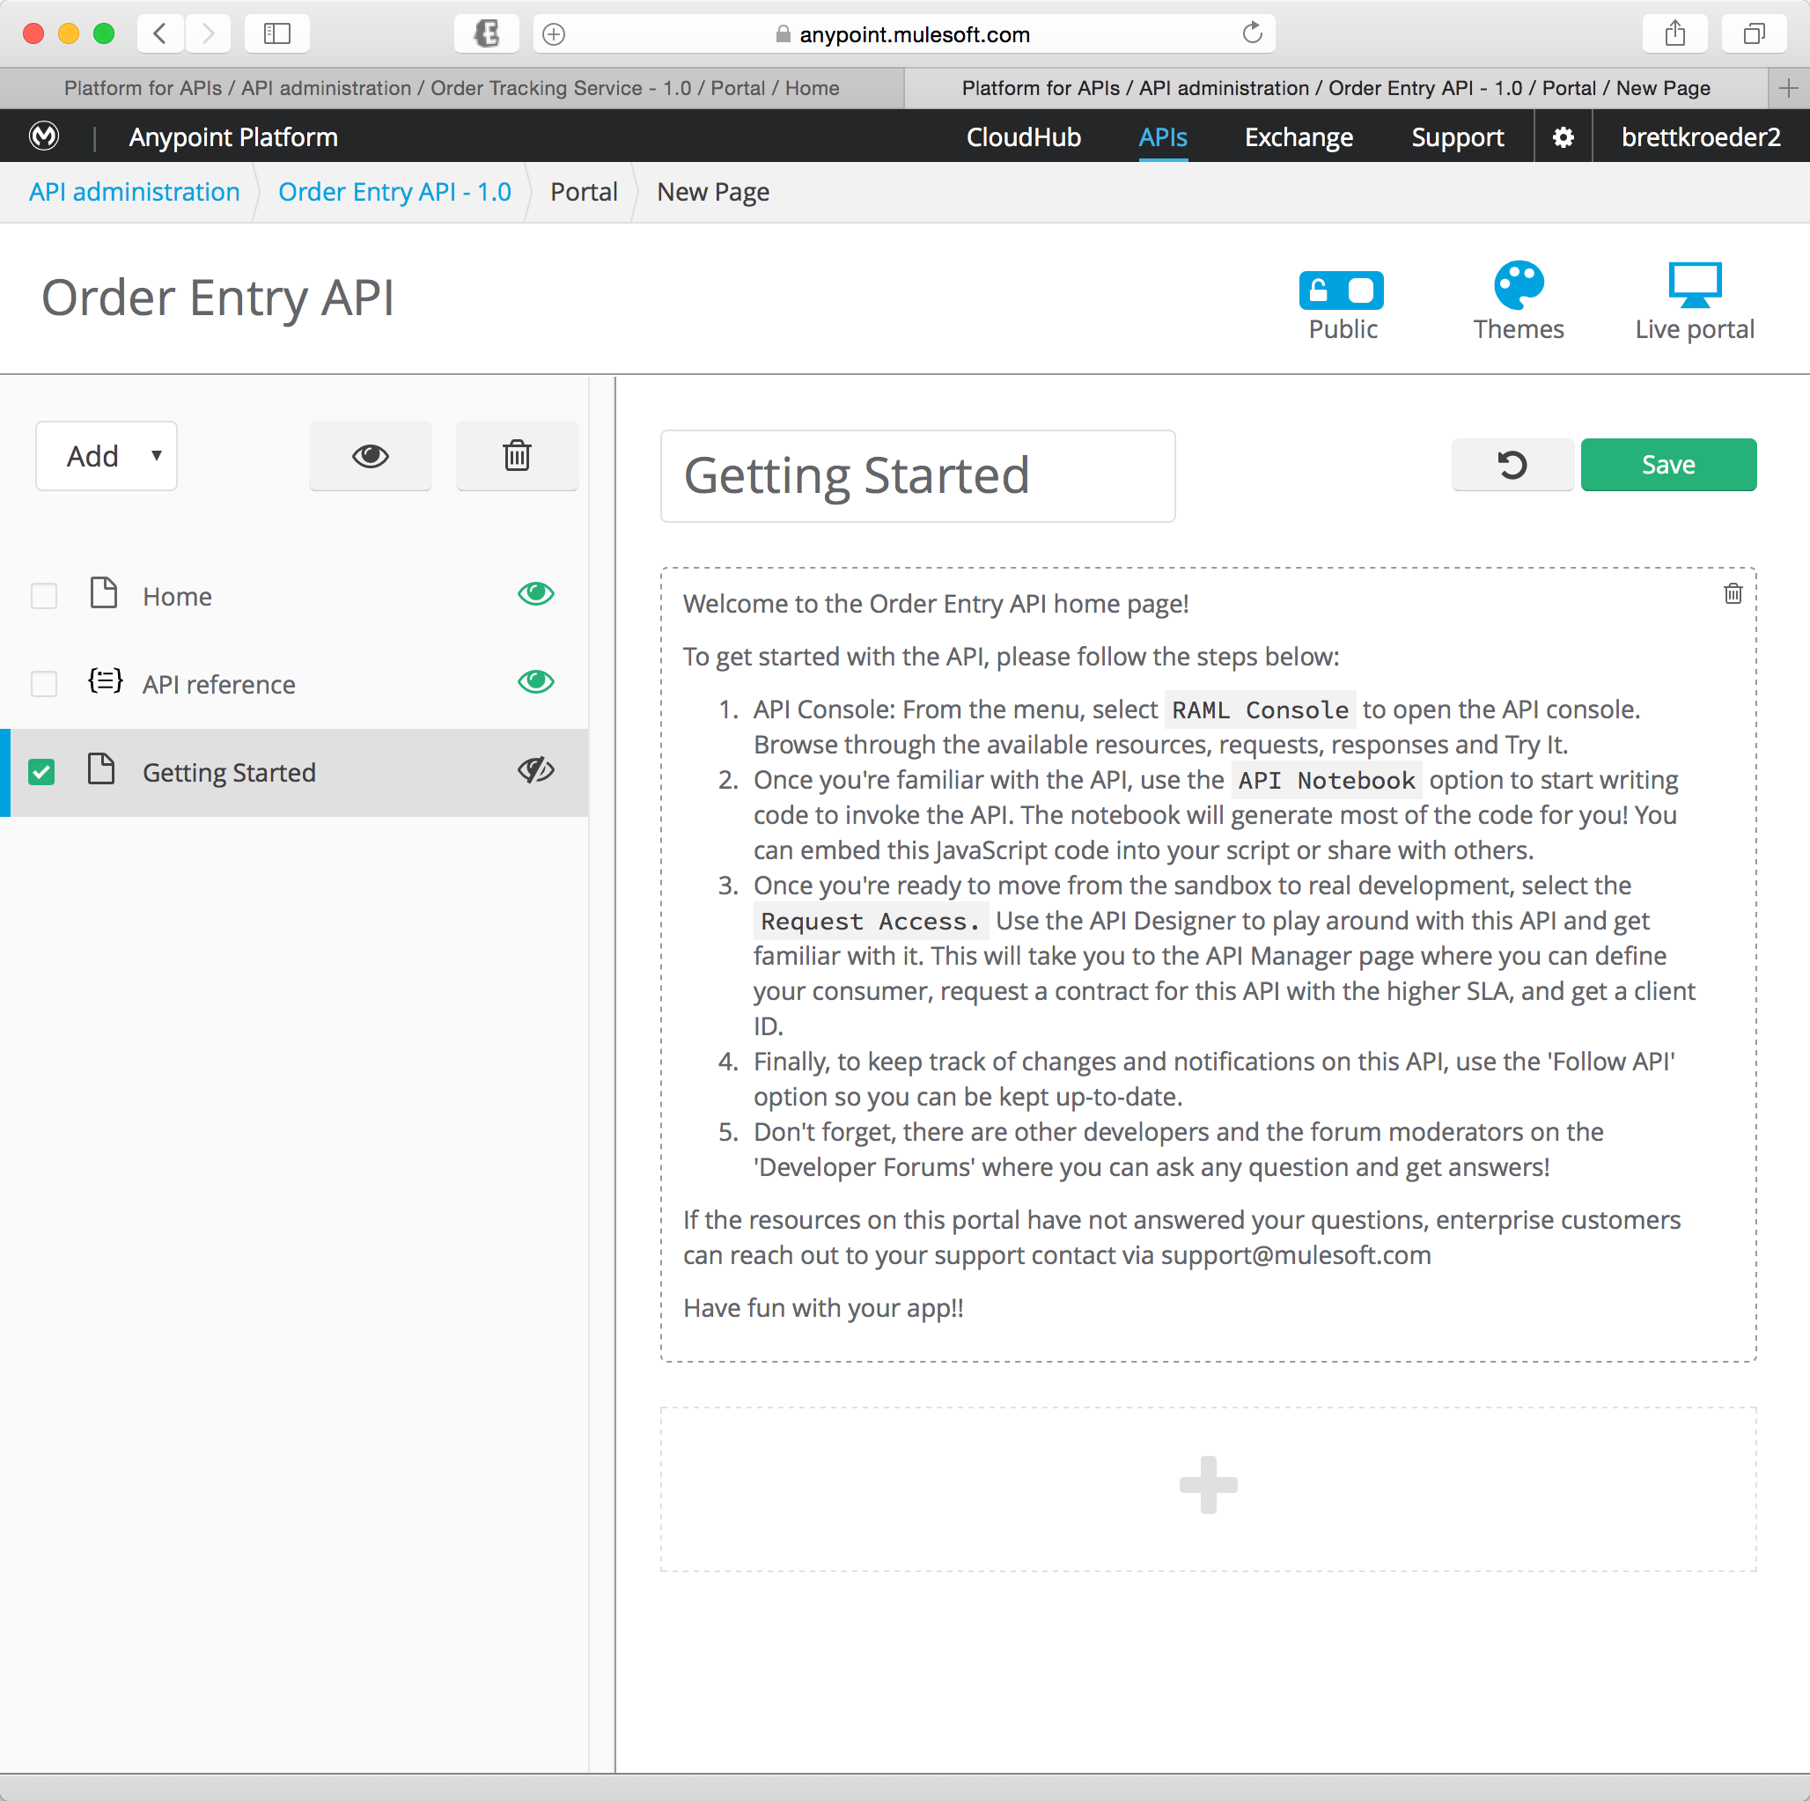

1. Click **Save**
2. Click the to make it **Visible**.

## Step 4: Create a Notebook

The API Notebook is an interactive JavaScript programming environment that can embed documentation. The Notebook generates an API client code based on a RAML API definition, so authenticated live calls can be made to the server, returning real-time information. You can use this code from API clients such as Node.js implementations or potentially within a web page or mobile apps.

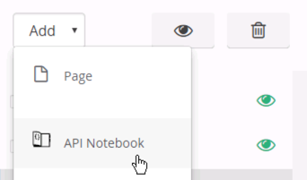

To create a Notebook for the Order API,

1. Click **Add**
2. Click **API Notebook**. This will create a new notebook that you can use to query the API found in the RAML URI.

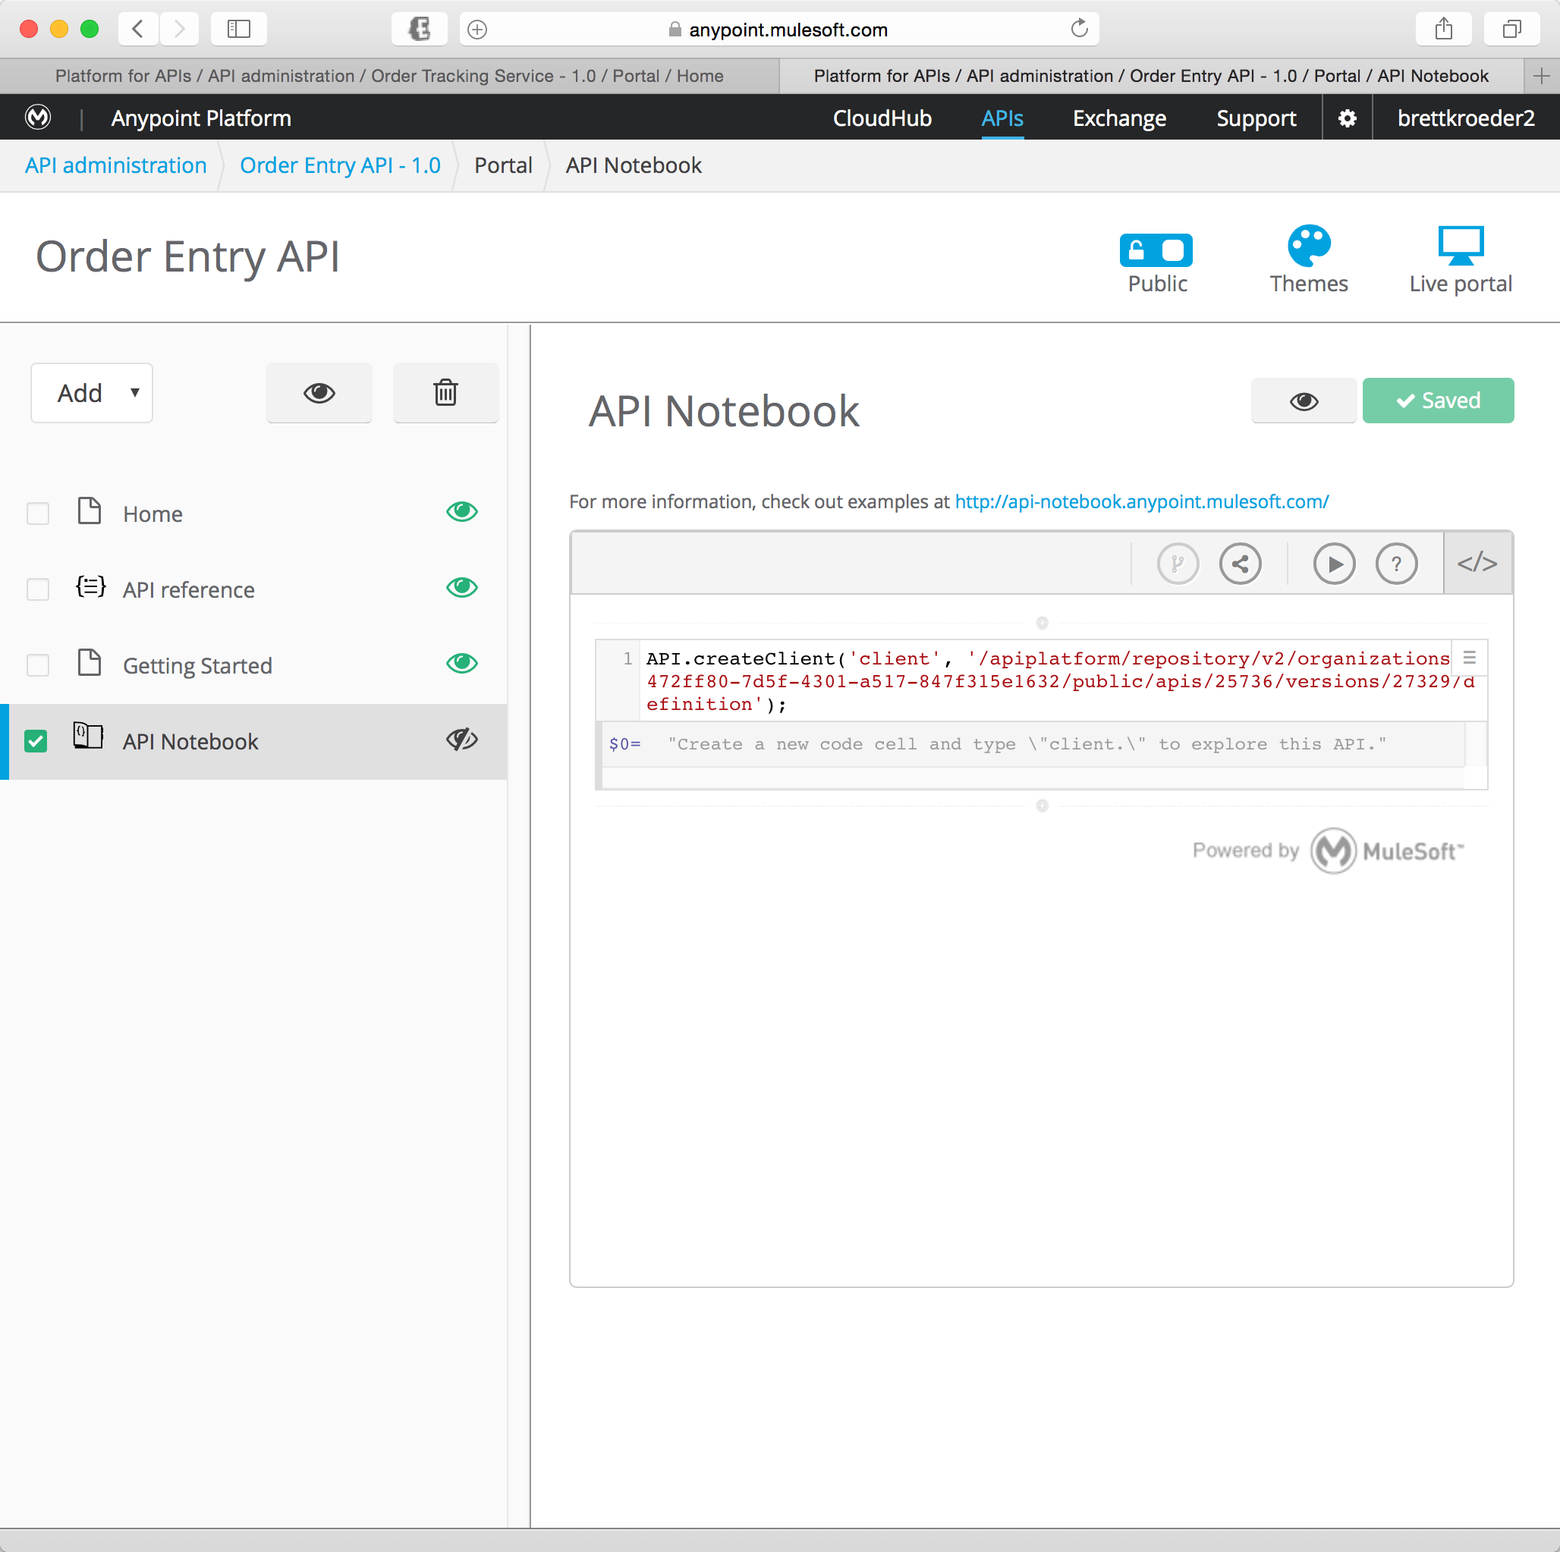

1. The first line is automatically created for you. It creates a client that you can use for testing.
2. Click the line
3. Click the Play button to execute.

You will add the second line to test the API.

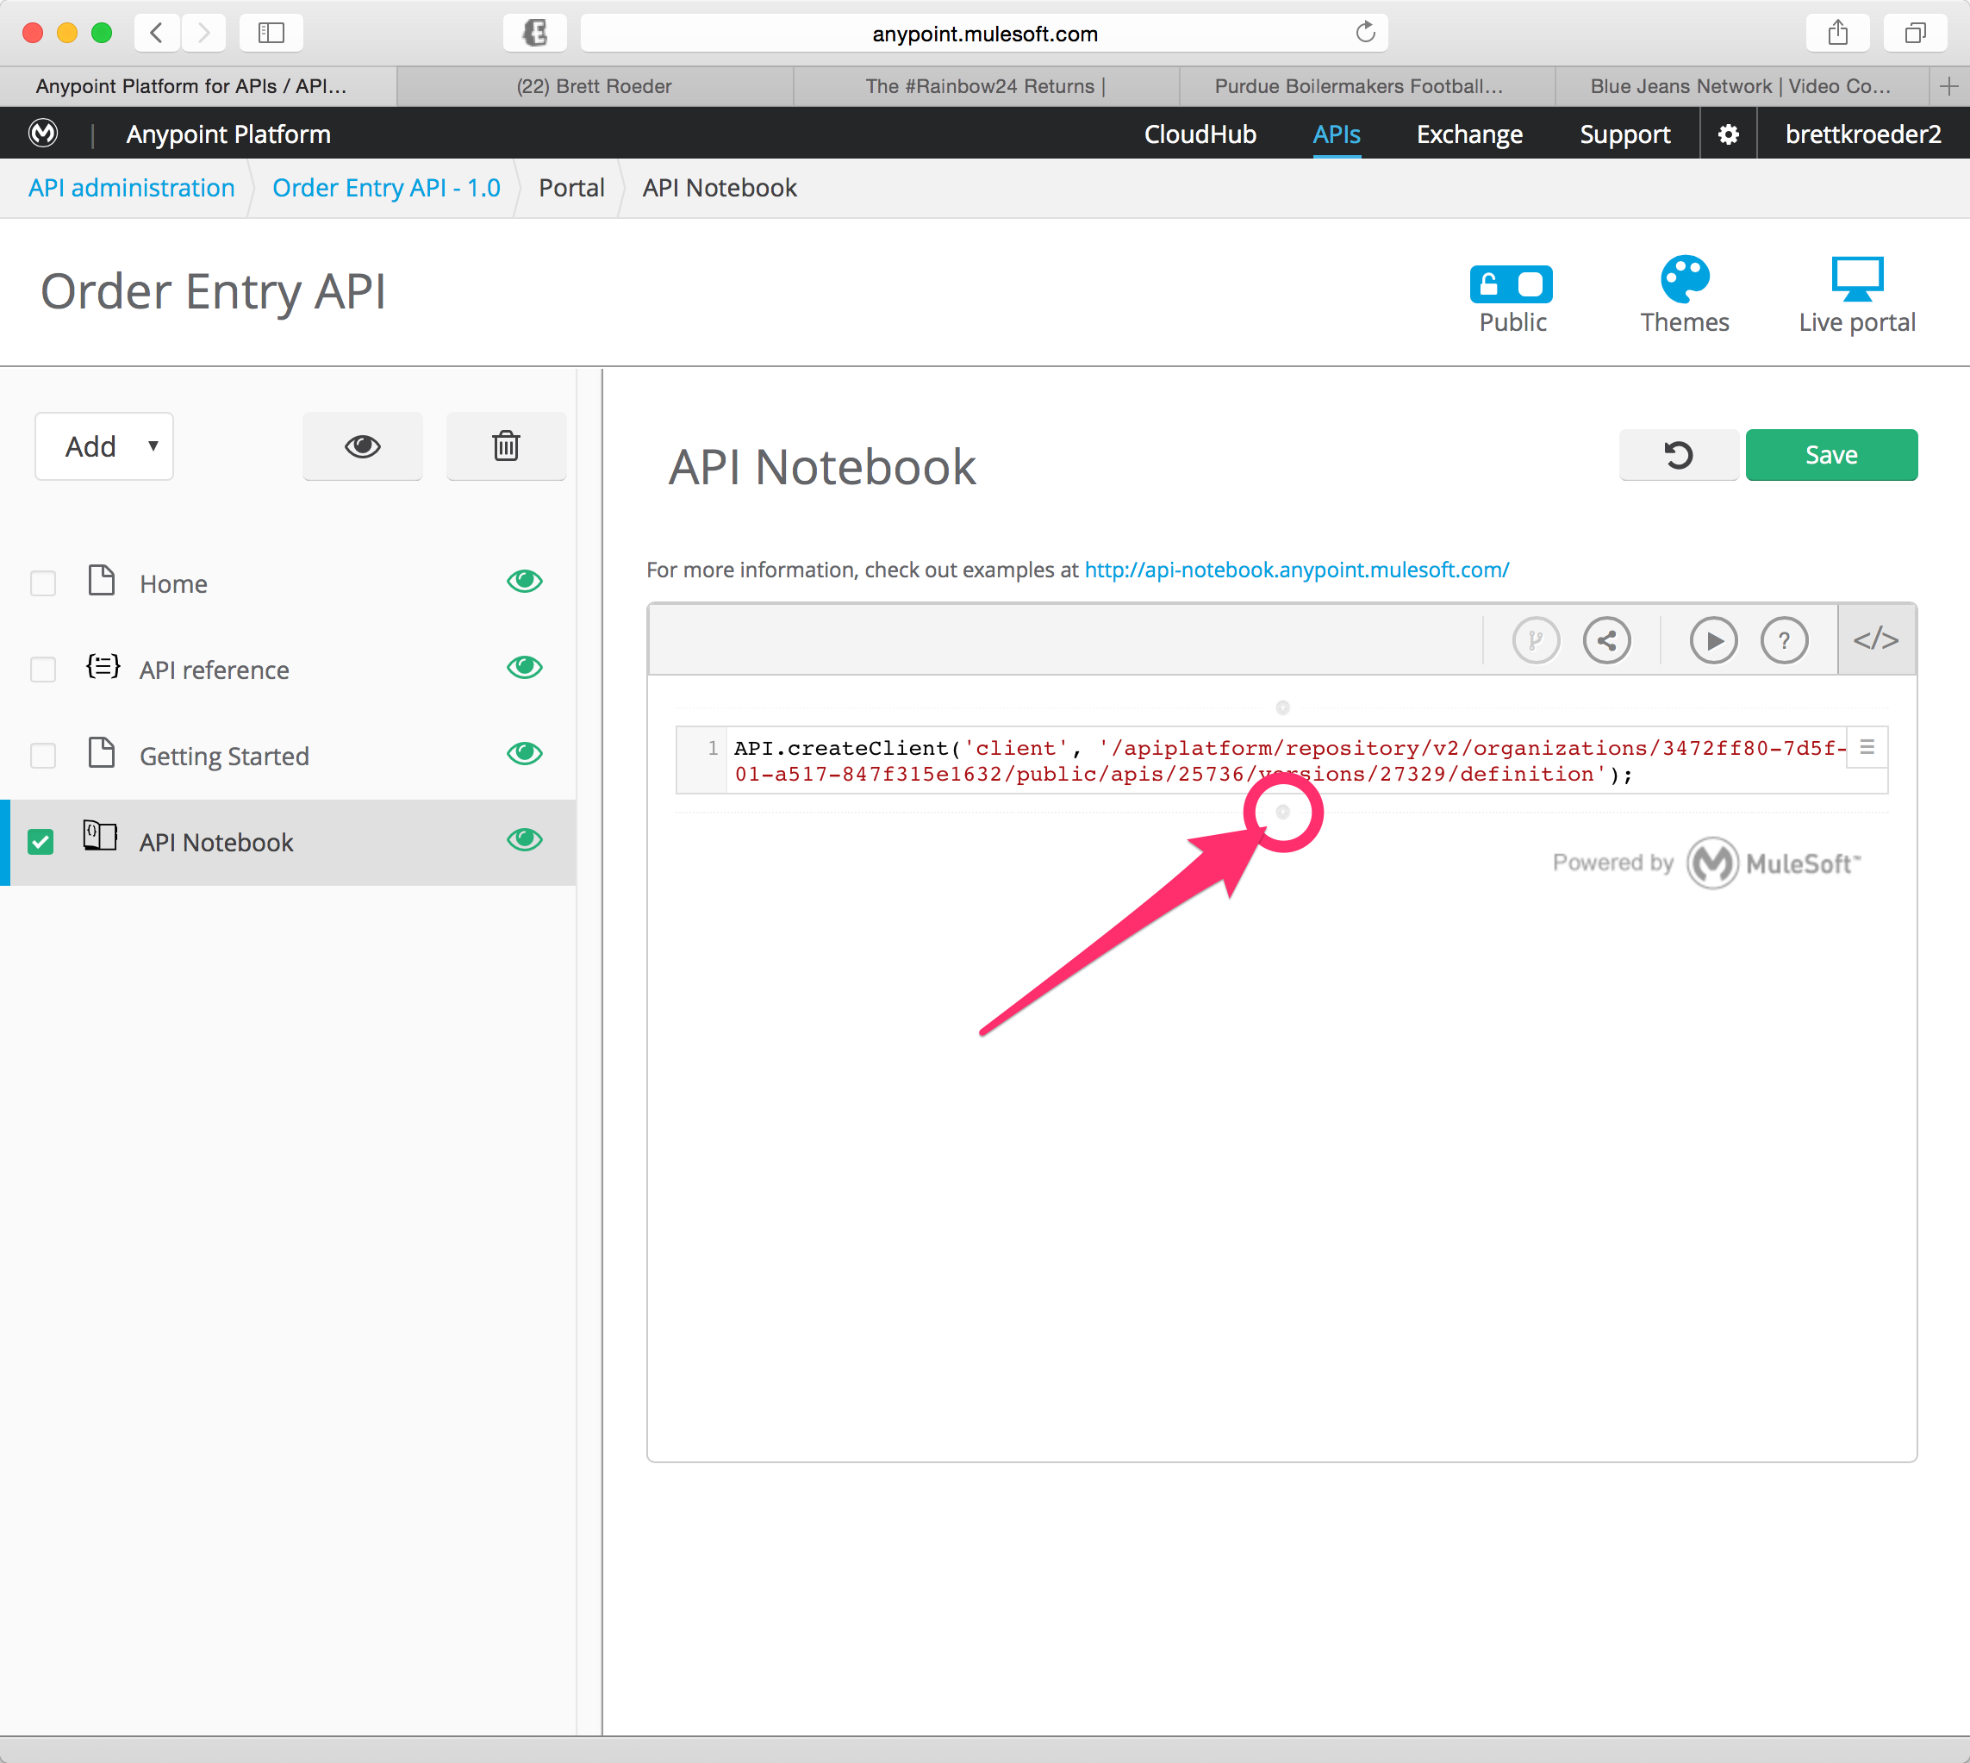

1. Click on the button at the bottom of the **API.createClient** script to Insert a new code cell

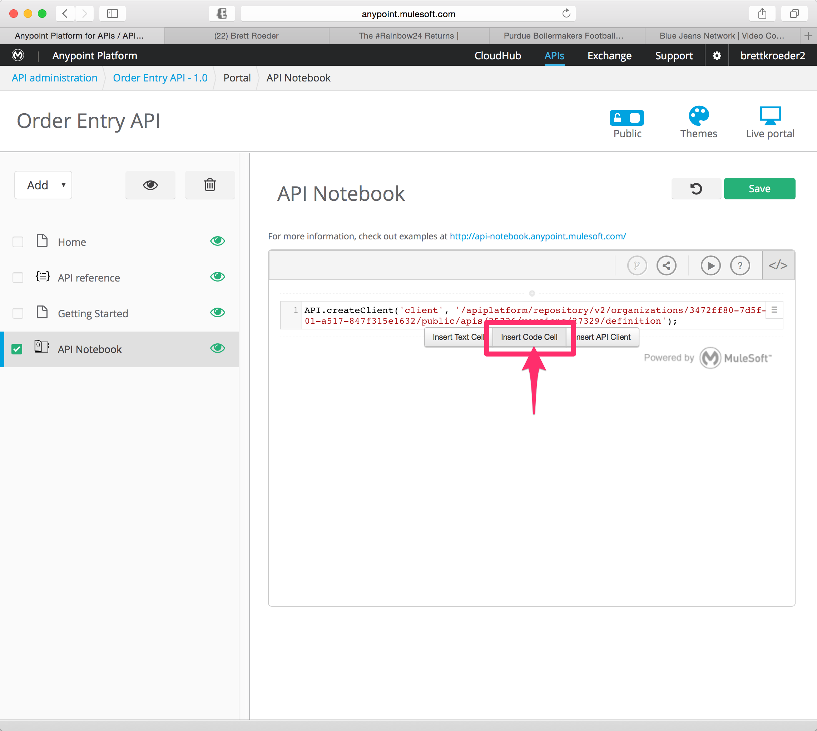

This will display your options.

1. Click on **Insert Code Cell**

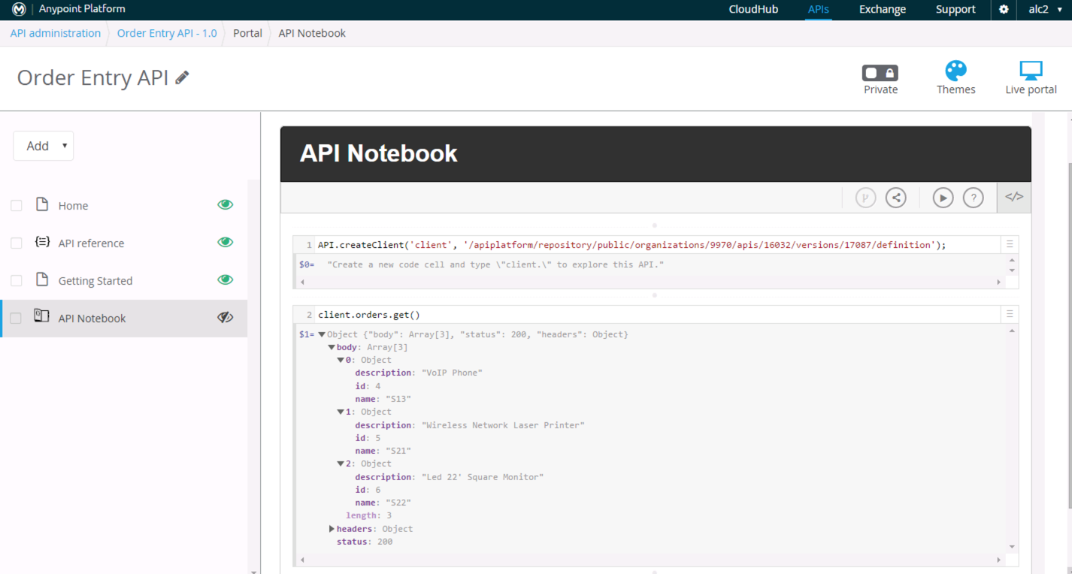

1. Add the following code client.orders.get()into your new **code cell**.
2. Press enter to execute the line.

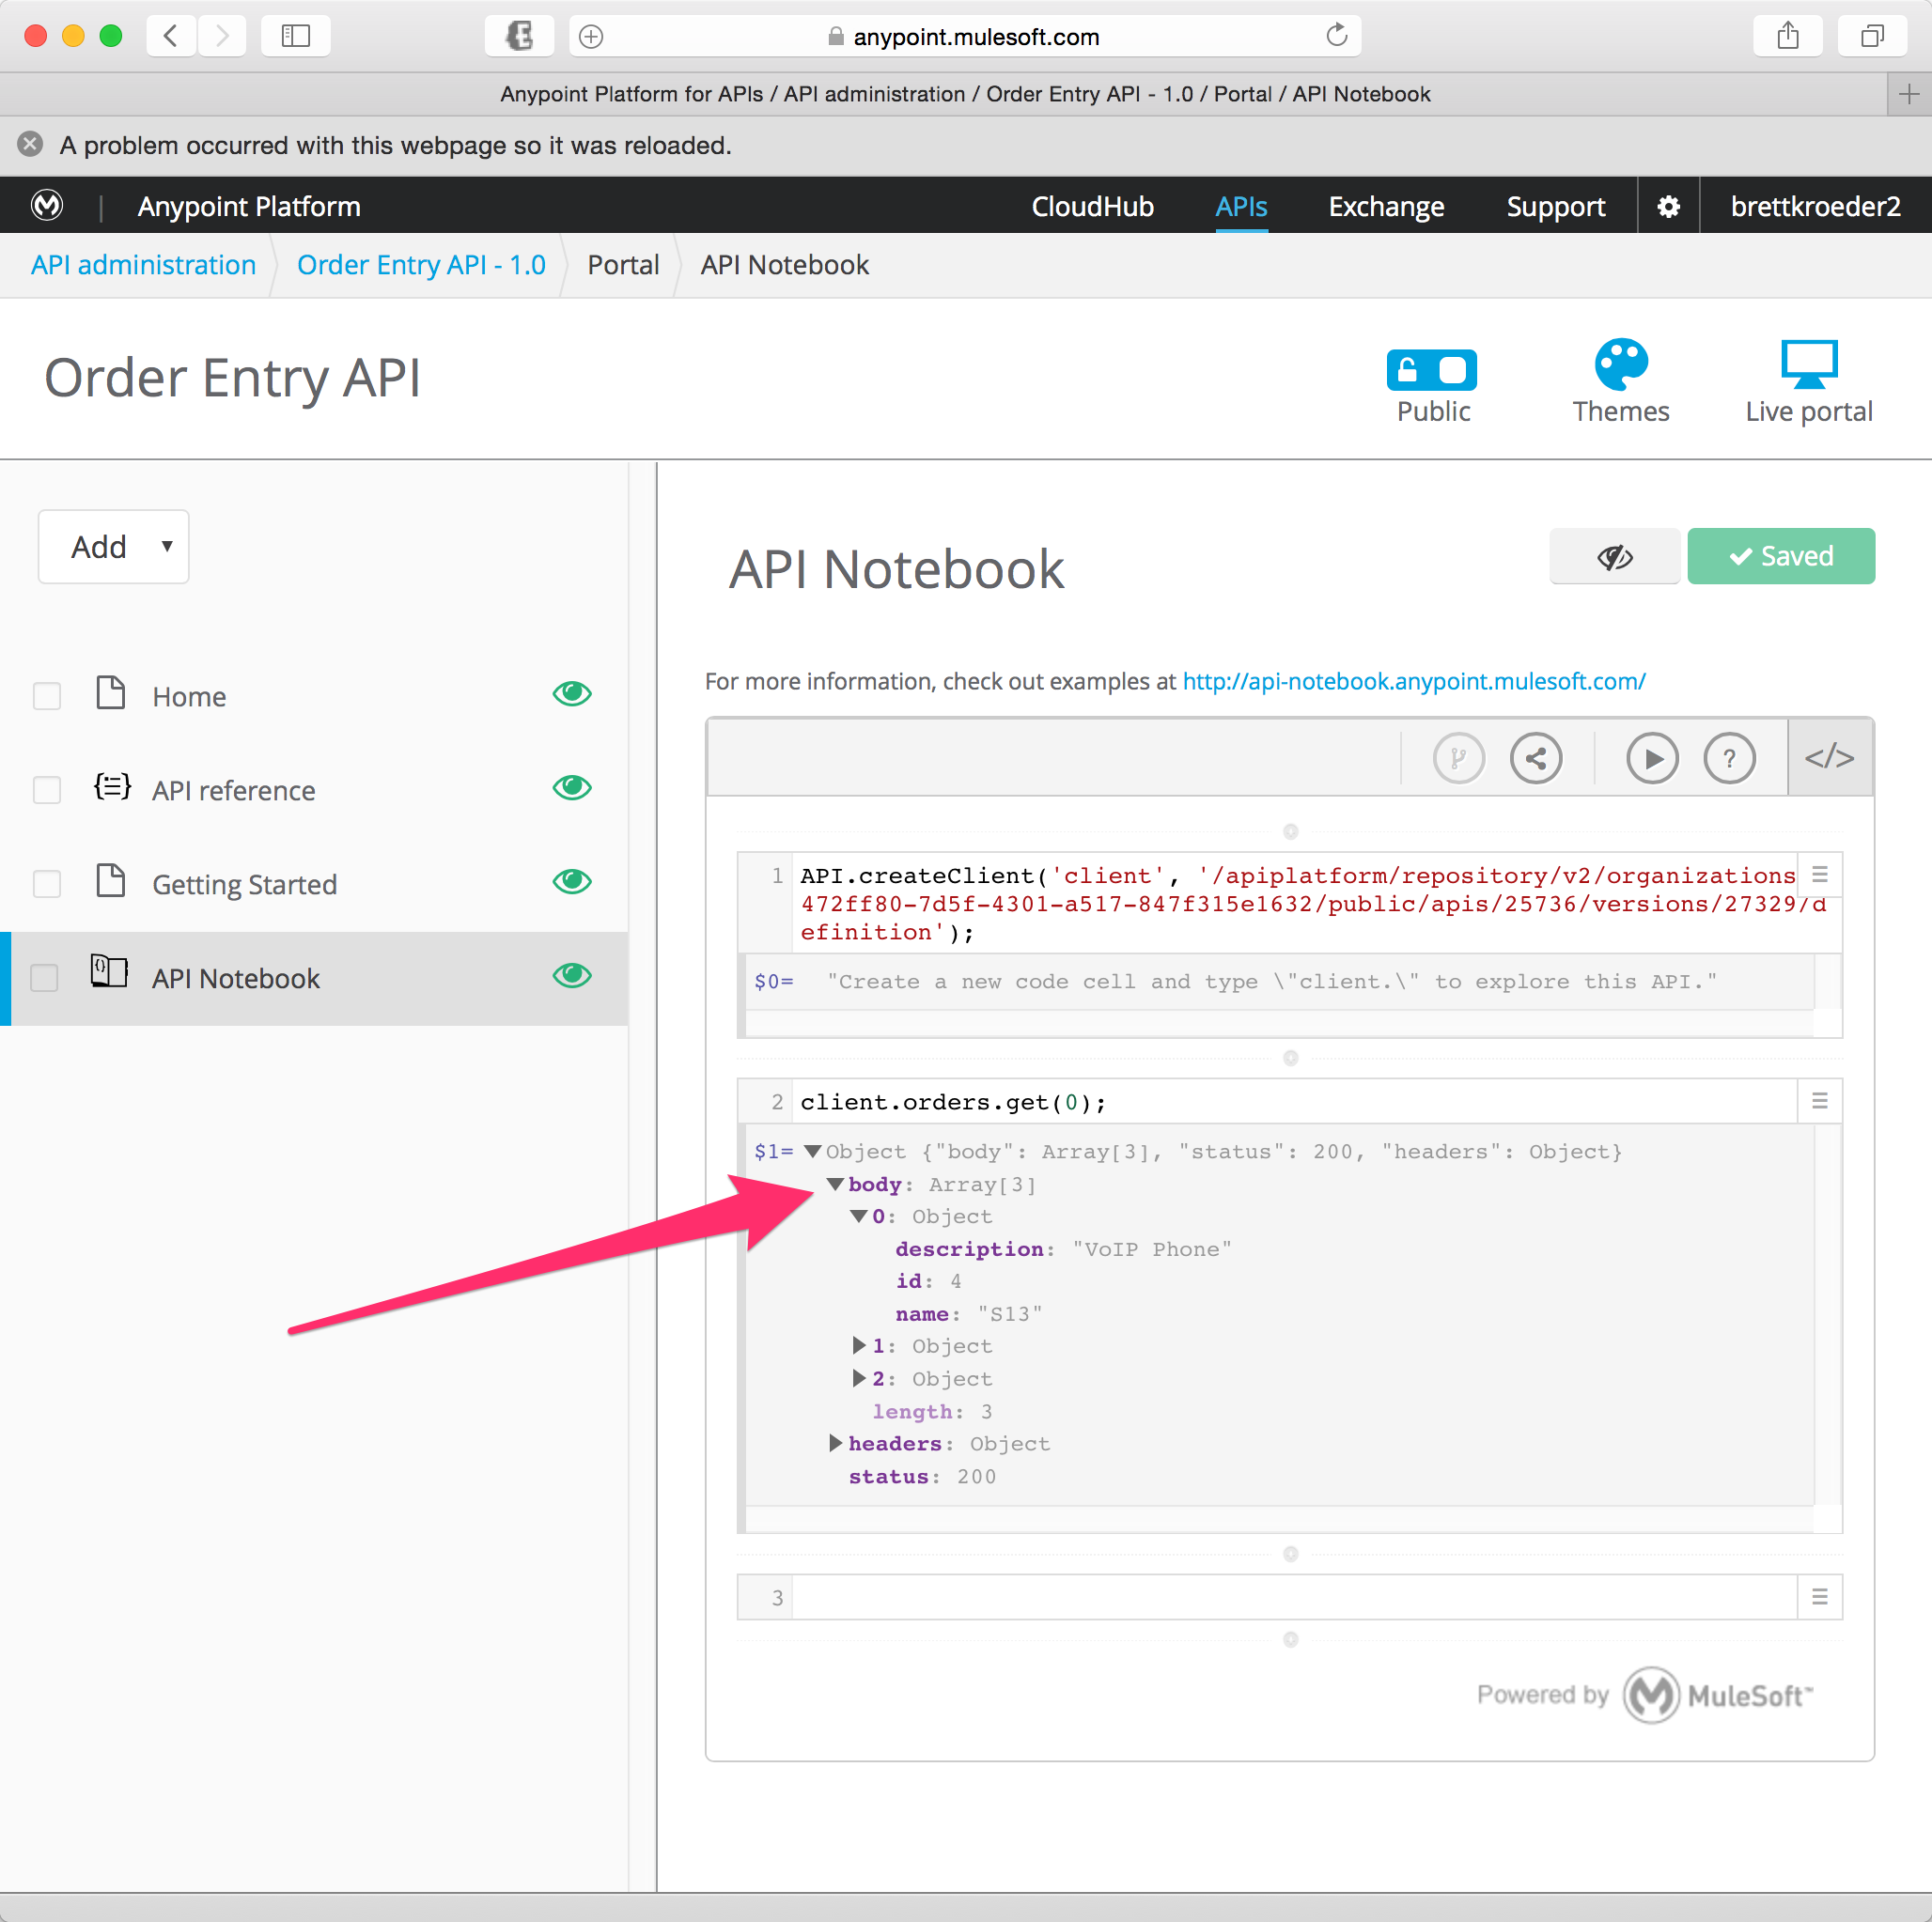

1. Expand the **body** and you should see your sample response.

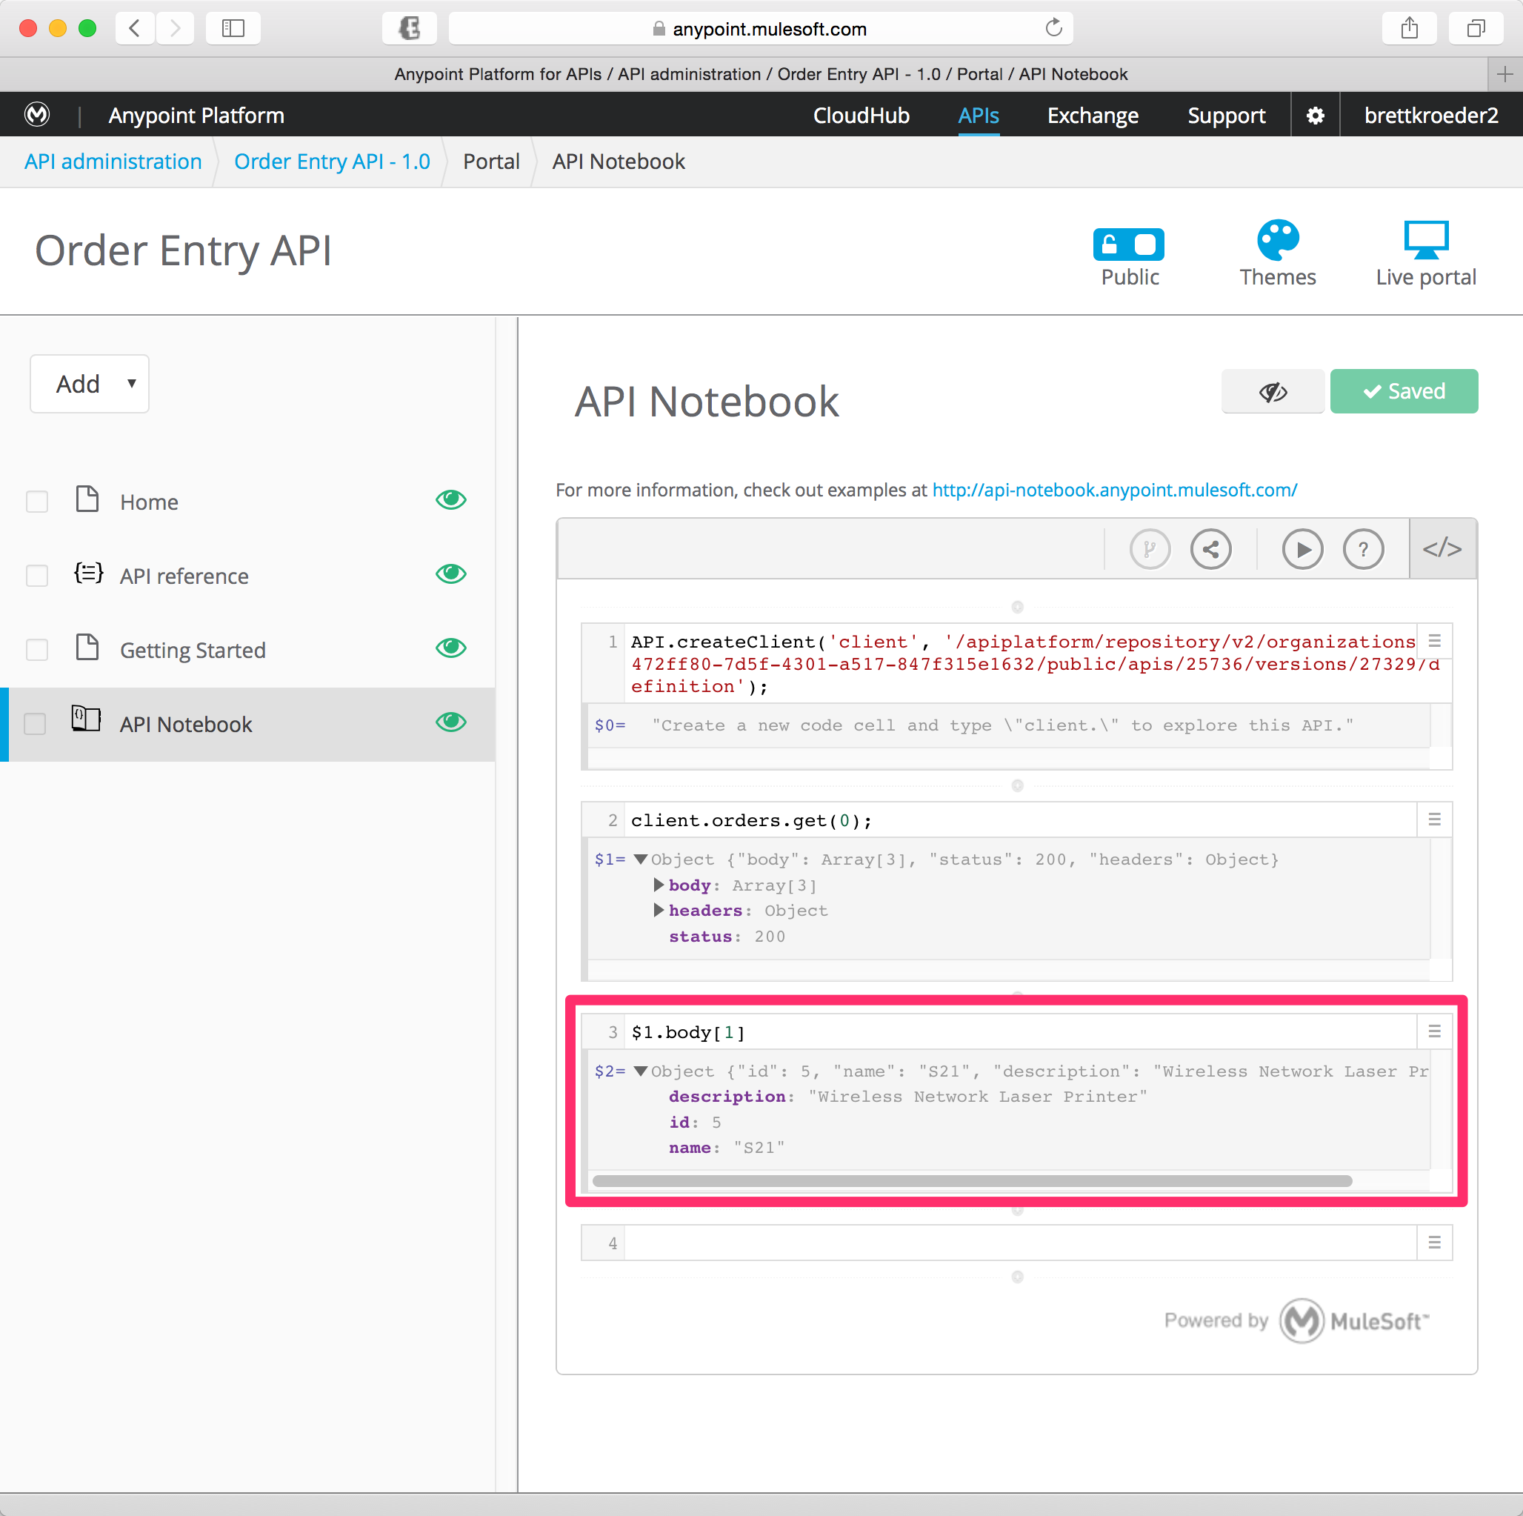

Optional: You can continue adding code here to retrieve the body response for example:

$1.body[0]

This will retrieve the first element in the array as arrays are zero based.



1. Click **Save**
2. Set the page to **Visible**.

**Step 4: Edit the Home Page**

Let’s add more content to the home page.

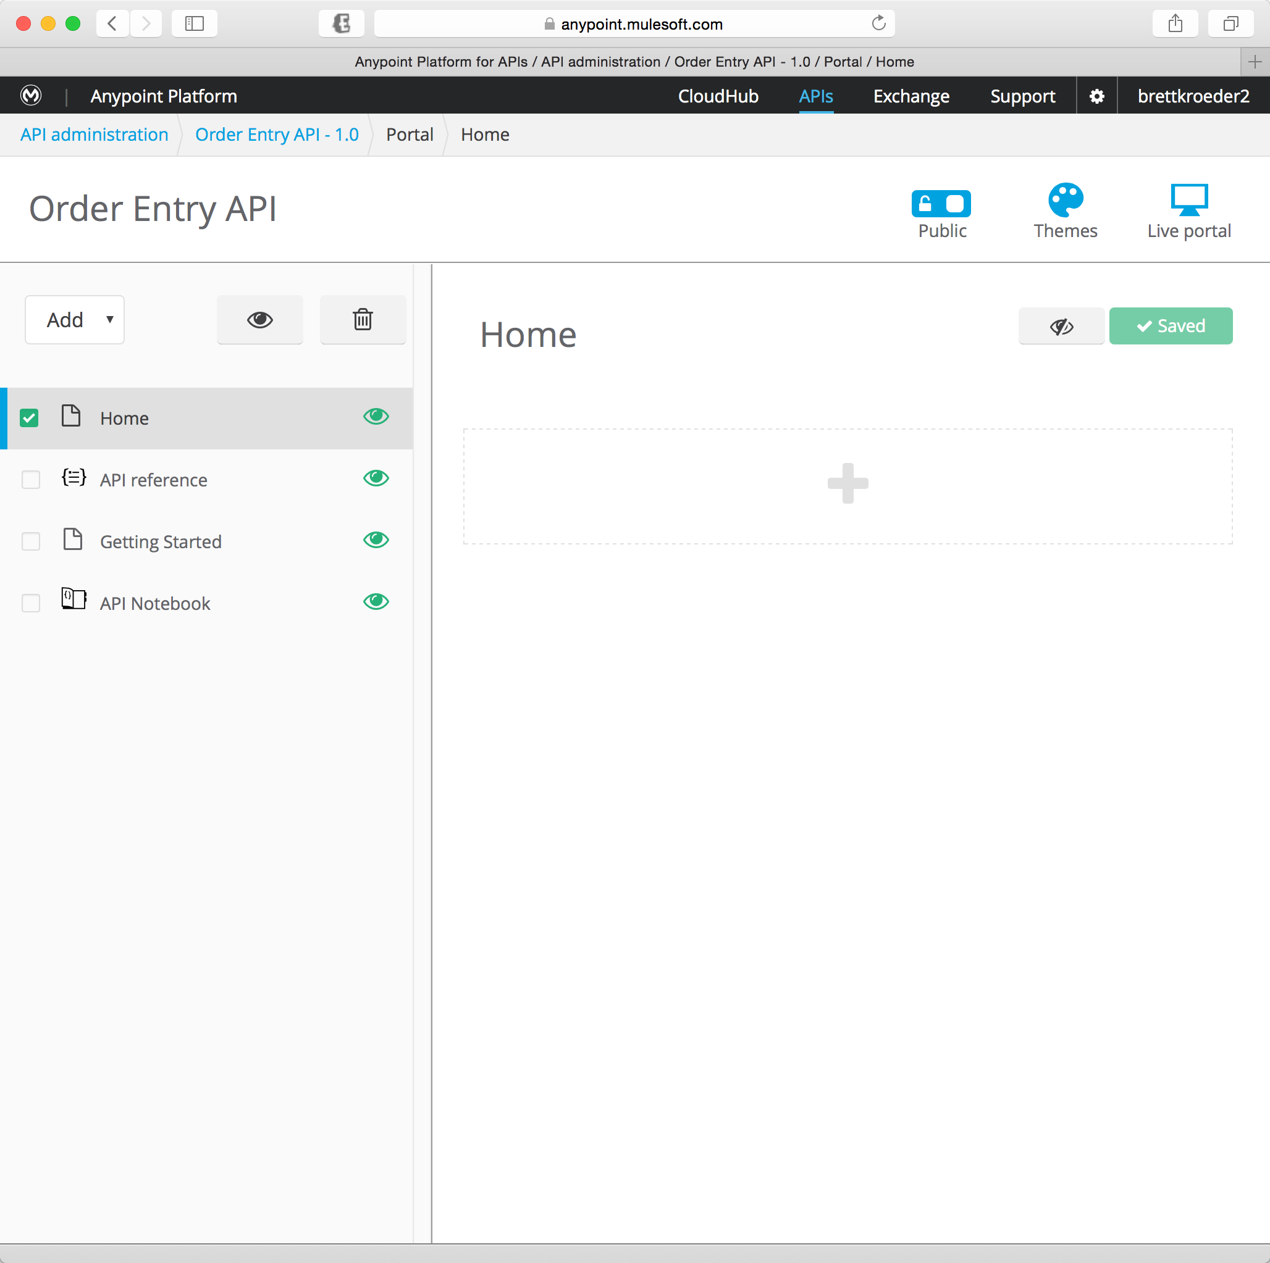

1. Click the **Home** page.

|  |
| --- |
| **NOTE**: You can copy-paste the text below from the soft-copy of the Workshop Guide, which is available as an icon on your Desktop. |

1. Copy the following text

|  |
| --- |
| Welcome to the developer portal for the Order Entry API. This API allows users to create orders and retrieve order status. This portal has been developed to provide a self-service way for users to discover, test and sign up for API access.  The API developer portal includes the following:  * Getting started  * RAML console - API reference  * API Notebook  The architecture of the Order Entry API:  ![](http://www.anypoint-workshop.com/images/alc.png) |

|  |
| --- |
| **Remember…** your page can be formatted using [GitHub Flavored Markdown coding](https://help.github.com/articles/markdown-basics/). |



1. Click **Save**

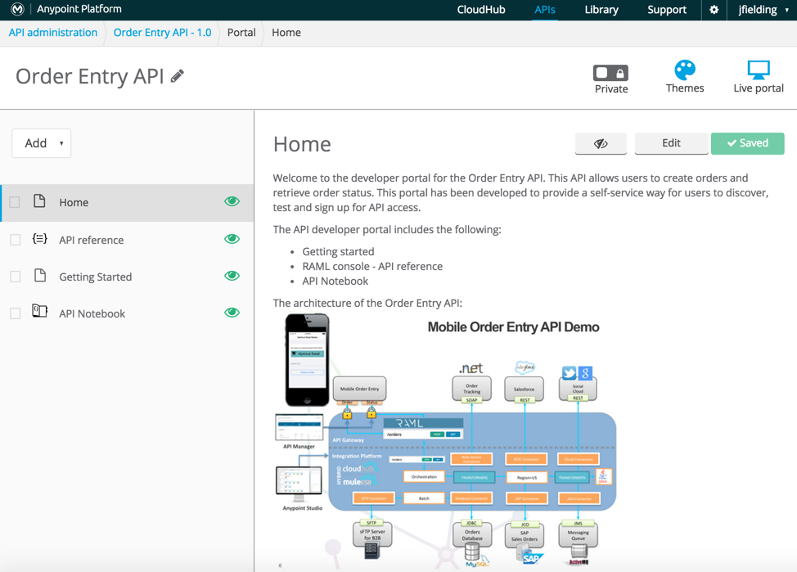

**Step 5: View your Live Portal**

1. Click theicon to view your portal.
2. Explore your portal!

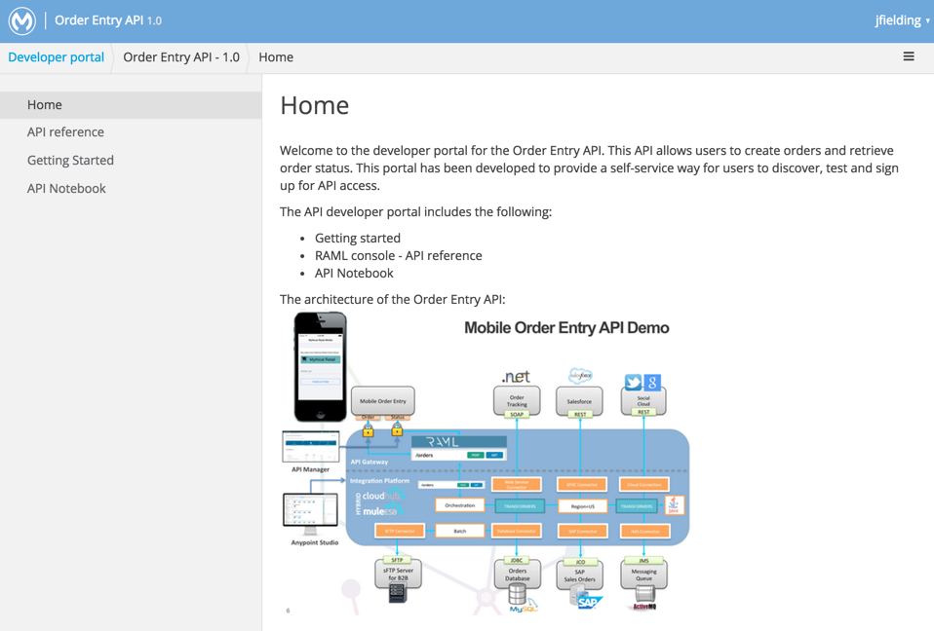

## Summary

The API Portal aims to provide an engaging website for your API consumers to interact, learn and request contracts for using your API. The API Portal **facilitates collaboration** between API and application developers throughout all of the stages of the API life-cycle, facilitating continuous improvement of the API. It also serves as a central repository for all APIs developed where they can be **easily discovered and consumed**.

See [Engaging Users of Your API](http://www.mulesoft.org/documentation/display/current/Engaging+Users+of+Your+API) for more information.

Congratulations! You have finished Lab 5.

Please update the spreadsheet indicating you have completed Lab 5.